Observations:

1. There is less space gap between Login and email, should be more space gap as per wireframe.
2. The visibility option is not visible as per wireframe.
3. The name of login button is not as per wireframe.
4. Sign up hyperlink color is not as per wireframe.
5. Forgotten password hyperlink is not given in the wireframe.
6. There is less space gap below the submit button. There should be more space gap as per wireframe.
7. Login and signup button are not there at the top right corner as per wireframe.

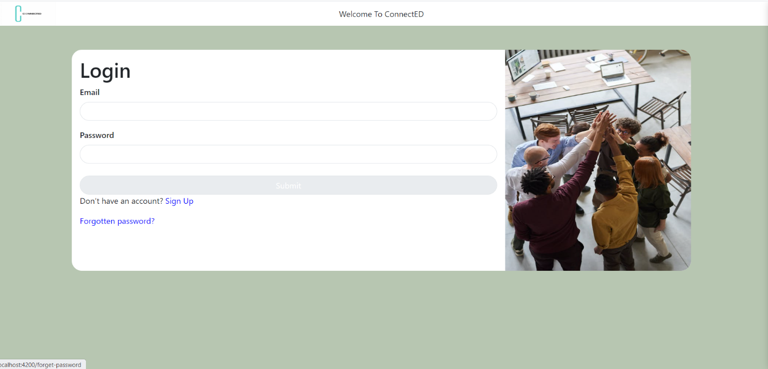

Wireframe:

